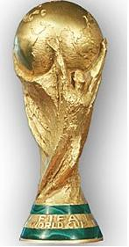
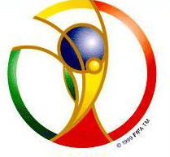

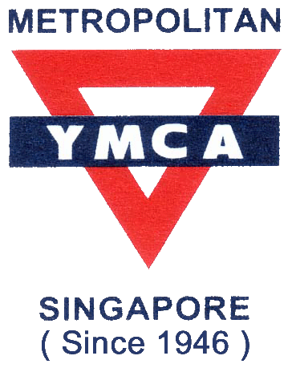
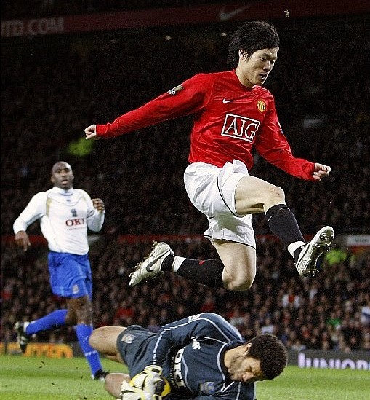
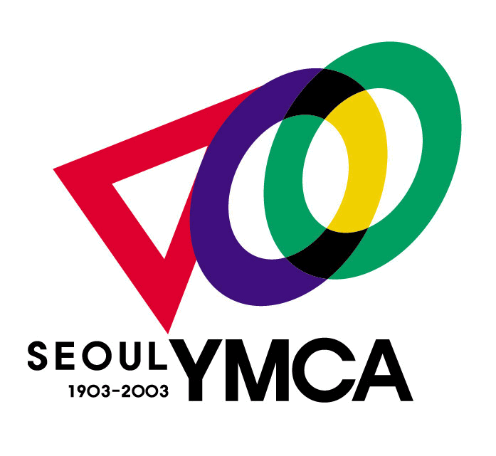
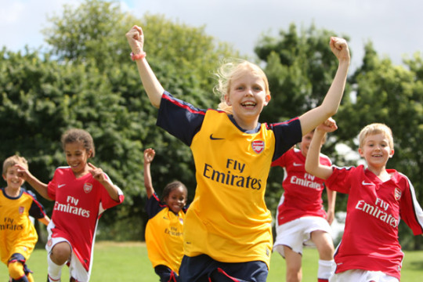
* 2010 KIDS WORLDCUP in SEOUL
> KOREA, USA, JAPAN, CHINA, TAIWAN, SINGAPORE
KIDS SOCCER TEAM JOIN THIS MATCH
> DATE : 16 to 21 Aug 2010
> VENUE :SEOUL, KOREA / OLYMPIC PARK
> AGE: 10-12years old students (13 vacancies)
> PROGAMMES : INTERNATIONAL SOCCER MATCH
SEOUL TOUR & WATCH CULTURE CONCERT
RELATIONSHIP WITH WORLD KIDS SOCCER TEAM LOTTE WORLD TOUR etc.
> FEE : FREE(except, air ticket)
> Tel. 6839-8344 / Mr.KIM 9147-3396

* MYMCA 어린이축구교실
> 시 간: (토) 오후3시-4:30
> 대 상:초등학생 및 유아
> 활 동: 축구기본기술, 개인기술
미니게임, 실전 매치 등
> 참가비: $256.80
> 입 회 어린이에게 T-셔츠 증정
- THIS PROGRAMME MADE FOR SOCCER KIDS BY SEOUL YMCA / METROPOLITAN YMCA.
서울YMCA

