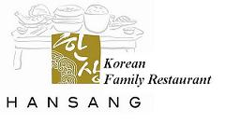

**Mijin & Co.Pte Ltd**

**10 Sinaran Drive #03-33 Square 2 Singapore307506** Hansang Korean Family Restaurant, Novena SQ2

Hansang Izakaya & Charcoal BBQ, Holland Village

Hansang Korean restaurant & Market, Turf City