Moving out Sale
TV & TV Table | $30 | Washing Machine | $120
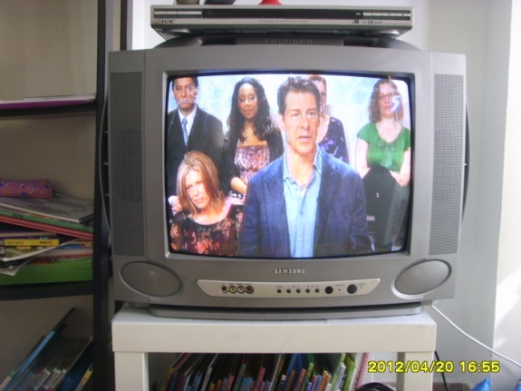 |  | 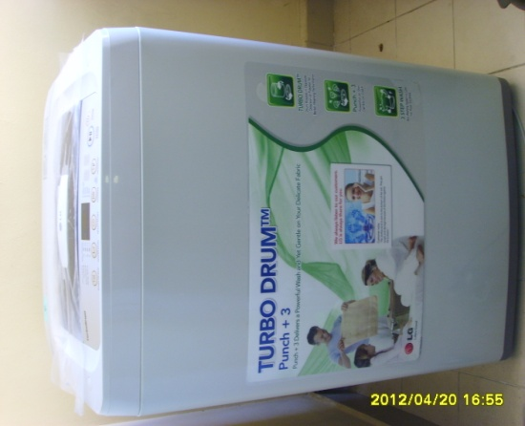
Good Working |  | Only 9 months use
Chair X 3 | $10 | Portable Air Con | $150
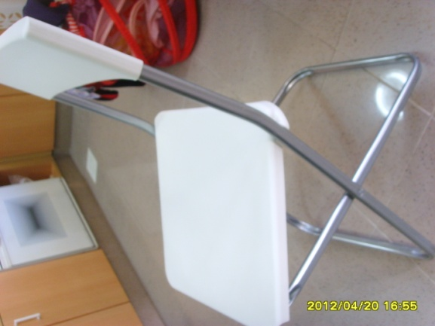 |  | 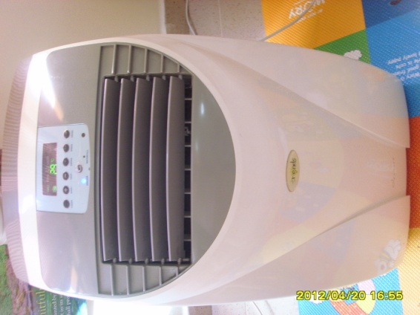
IKEA |  | 18,000BTU & Ionize function

- Call or SMS to 9812-2635 by the end of April

98122635 | 98122635 | 98122635 | 98122635 | 98122635 | 98122635 | 98122635 | 98122635 | 98122635 | 98122635

